Progress Report 4
Evaluating Intent Based and Self Healing Locator Strategies for Robust Browser Workflow Automation
Gabriel Anokye | Senior Seminar | November 10, 2026 | Weeks 10 to 12
Repository: github.com/GabrielAnokye/waypoint | Phase 2 completion, Phase 3 benchmark, Phase 4 self healing

Research question and result
This project asks how well recorded browser actions survive realistic changes to a page and whether a cautious repair algorithm can recover broken actions without selecting the wrong element. During Weeks 10 to 12, I completed six deterministic mutation classes, captured element features at recording time, ran a four-family benchmark, and added self healing to the Waypoint runner.
The controlled N=5 matrix contained 16,800 action trials per pass. Correct-target actions rose from 11,140 (66.31%) with healing disabled to 13,749 (81.84%) with healing enabled, an increase of 2,609 actions or 15.53 percentage points. Of 5,524 attempted repairs, 2,609 were correct, none were incorrect autonomous repairs, 2,390 stopped for manual review, and 525 were unrecovered. These are measured outcomes on a fixed synthetic corpus; they are not end-to-end workflow completion rates.
Measure | Baseline pass A | Healing pass B
Action evaluations | 16,800 | 16,800
Correct target | 11,140 (66.31%) | 13,749 (81.84%)
Wrong target | 136 (0.81%) | 136 (0.81%)
Safe failure or refusal | 5,524 (32.88%) | 2,915 (17.35%)

The 136 wrong-target actions in each pass came from baseline locators that resolved to a unique but incorrect control. Healing runs after locator failure and therefore did not detect or change those actions. Zero wrong autonomous repairs is a narrower finding than zero wrong actions.

Implementation completed

Phase 2 mutation engine and corpus
The fixture server applies a poorly labeled variant before mutations and accepts a deterministic seed. Eight base fixture pages plus eight poorly labeled variants produce 16 page states. Each has controlled cosmetic, attribute, structural, layout, content, and semantic perturbations. The ground-truth ID is excluded from mutator writes and healing features.
Condition | Change under test
Cosmetic | Seeded class renaming with matching style and fixture-script references.
Attribute | Seeded ID and test-ID renaming with label and ARIA reference updates.
Structural | Valid wrappers around interactive controls, retaining table ancestry and slot behavior.
Layout | 80 to 250 px outer-page translation; seed=demo shifts 231 px.
Content | Copy changes such as Sign in to Log in to Account and Delete to Remove Item.
Semantic | Removes explicit ARIA/label ties and turns eligible buttons into styled keyboard-focusable divs.
Unlabeled variant | Removes redundant test IDs and explicit ARIA labels before mutation.

The immutability audit found 177 source truth-ID declarations across eight files. All 2,478 compared anchor occurrences were preserved across 112 transformed document checks, with zero changed. Some source declarations appear in templates or iframe content and expand into multiple runtime elements; 177 is not a count of simultaneously visible controls.

Phase 3 benchmark harness
The canonical suite contains 16 workflows and 120 recorded target actions covering forms, tables, dropdowns, delayed controls, iframes, open shadow DOM, a single-page app, and ambiguous controls. For each action I captured four locator families: coordinates, structural CSS/XPath, intent-based names/labels/text, and test contracts. The harness isolates each family against seven conditions, including no mutation, over five deterministic seeds. It executes 120 × 4 × 7 × 5 = 16,800 independent action trials in each pass, plus 840 forced-broken Delete threshold trials.
Each trial starts from a fresh page with fixed prerequisite state. A preserved data-truth-id is read after target selection only to grade correct, wrong or safe non-execution. A family that has no recorded locator contributes a safe failure rather than an invented test ID. Closed shadow roots are present in the corpus but excluded from the 120 evaluated actions.

Phase 4 scored recovery
When all recorded locators fail, the runner enumerates visible interactive controls in the recorded frame and compares each with the capture-time snapshot. The score combines semantic role and accessible name (0.35), text (0.25), stable attributes (0.20), ancestor/sibling structure (0.10), and viewport-center distance (0.10). These scores rank similarity; they are not calibrated probabilities.
S(e,s) = 0.35 sem + 0.25 text + 0.20 attr + 0.10 struct + 0.10 pos
The runner repairs automatically only when the top score S1 is at least 0.75 and its lead over S2 is at least 0.15. Scores from 0.50 to below 0.75, or a smaller lead at higher scores, stop for manual review. Below 0.50, the step is unrecoverable. Migration 005 persists the attempted flag, outcome, score, margin, regenerated locator, top three candidates, and latency. The generated selector is run-local and is not saved as a new workflow locator.
The 16,800 Pass B trials reused the same grading conditions as Pass A. Healing was attempted on 5,524 broken or ambiguous actions: 47.23% correct recovery, 0.00% wrong autonomous repair, 43.27% manual escalation, and 9.50% unrecovered. The repeat-run mean latency was 38.205 ms and P95 56.184 ms under four browser workers. The published source run recorded 30.901 and 45.752 ms respectively; outcome counts matched, while timing varied with execution conditions.

Empirical findings

Locator survival before healing
The families fail in different ways. Coordinate actions survive copy and attribute changes but collapse under layout movement; structural selectors fail heavily when wrappers alter hierarchy; intent locators suffer under semantic degradation; and test contracts vanish under attribute renaming or poorly labeled variants. The full 28-cell matrix appears in Appendix A.
Family | Correct | Wrong | Safe failure | Correct rate
coordinate | 3380 | 126 | 694 | 80.48%
structural | 3300 | 10 | 890 | 78.57%
intent | 2900 | 0 | 1300 | 69.05%
testContract | 1560 | 0 | 2640 | 37.14%

The starkest individual failures were coordinate under layout (0/600 correct; 86/600 wrong), structural under structural mutation (30/600 correct), intent under semantic mutation (110/600 correct), and testContract under attribute mutation (0/600 correct). These reflect the specific perturbations built into the corpus, not a universal ranking of locator families.

Recovery, safety and thresholds
The full recovery matrix appears in Appendix B. Correct autonomous recoveries were 444 for coordinate, 370 for structural, 180 for intent, and 1,615 for testContract attempts. Wrong autonomous recoveries were zero for every family. Semantic mutation remained hardest: 220 of 1,160 attempted repairs were correct, 415 required manual review, and 525 were unrecovered.
Policy | Trials | Correct | Wrong | Manual
Greedy top 1, 0.00 / 0.00 | 210 | 190 (90.48%) | 20 (9.52%) | 0
Permissive, 0.60 / 0.05 | 210 | 0 | 0 | 210 (100%)
Waypoint, 0.75 / 0.15 | 210 | 0 | 0 | 210 (100%)
Strict, 0.85 / 0.20 | 210 | 0 | 0 | 210 (100%)

The threshold sweep deliberately broke the locator on three visually identical Delete controls across both label variants, seven conditions and five seeds. Greedy top-1 executed 20 wrong clicks. Every gated policy refused all 210 trials, so these trials show the value of an ambiguity gate but do not establish that 0.75 / 0.15 is uniquely optimal. A high absolute score alone is unsafe when candidates nearly tie.

Visual verification in Waypoint
Figures 1 through 4 are genuine screenshots from an isolated local browser session using the built Waypoint extension and runner. The companion JSON records run status and actual trusted click events. The controlled Sign in workflow uses one test-ID locator so attribute mutation forces repair; a normal four-locator recording may succeed through a healthy fallback before healing runs. These screenshots illustrate execution behavior, while the benchmark tables above remain the experimental measurements.

Figure 1 Replay options in the extension
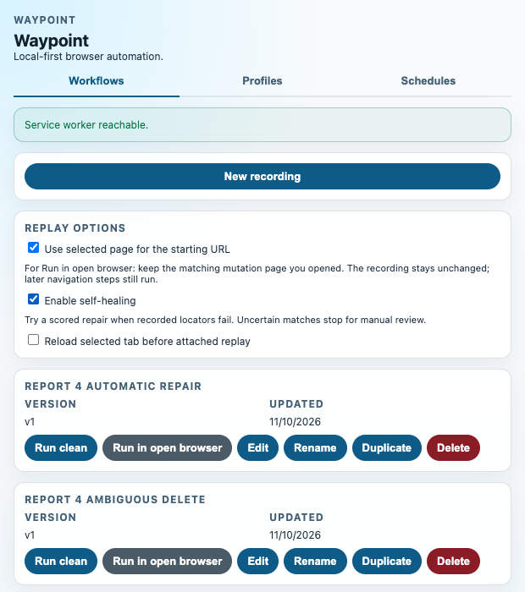
Figure 1. The selected page and self healing switches used for the browser demonstration.

Figure 2 Attribute mutation with healing off
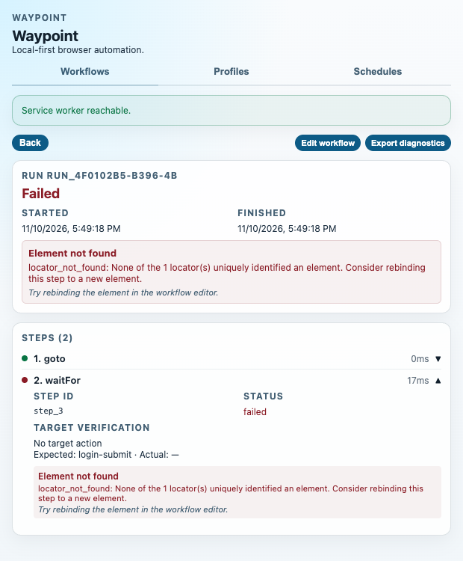
Figure 2. The recorded test ID no longer resolves. Replay stops at waitFor with locator_not_found and no target action.

Figure 3 Attribute mutation with healing on
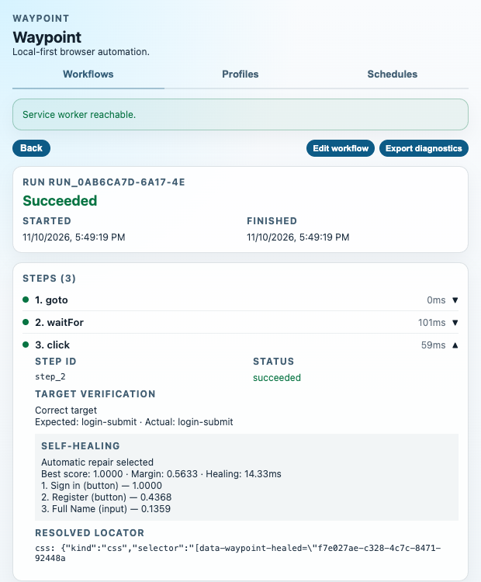
Figure 3. Waypoint repairs both waitFor and click. The click is graded correct: expected and actual truth ID are login-submit. S1=1.0000 and margin=0.5633.

Figure 4 Structural mutation and ambiguous Delete controls
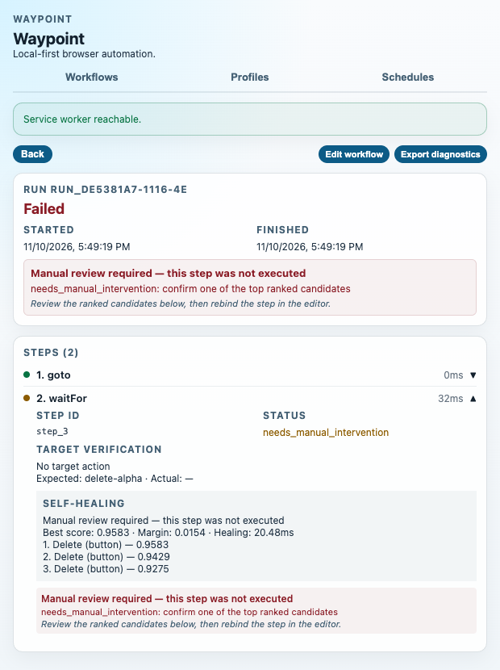
Figure 4. The top Delete score is 0.9583, but the lead is only 0.0154. The waitFor step stops before any Delete click.

Verification, challenges and limits

Repository and test status
At commit cace500, the repository had 39 commits and 173 tracked files, including 13,904 non-test TypeScript/TSX physical lines and 5,917 test lines across 30 test files. The source count includes 99 lines in root TypeScript configuration; application and package source alone totals 13,805 lines.
Verification | Observed result
pnpm test | 258 passed in 25 Vitest files
pnpm exec playwright test --config docs/verification-runs/weeks-10-12-review-2026-11-10/api-smoke.config.mjs | 7 API smoke tests passed
pnpm exec playwright test --config playwright.browser.config.ts --headed | 15 real-browser tests passed
pnpm typecheck | Passed
pnpm lint | Passed
pnpm build | Passed
pnpm benchmark:run | 16,800 A + 16,800 B + 840 threshold = 34,440 evaluations
node scripts/verify-benchmark.mjs | Counts, grading, gates, latency, hashes and suite integrity passed

The three test suites above contain 280 distinct passing cases: 258 Vitest, seven API smoke, and 15 real-browser. Benchmark trials are observations, not test cases.
The benchmark results came from the committed scoring and harness source at 86d9c7b. Commit cace500 added the selected-page replay controls and healing diagnostics after measurement; it did not change the scorer or harness. Current app tests exercise that later UI and attached-browser path. The complete raw observations and exact command transcripts accompany the evidence package.

Engineering problems resolved
- Structural wrappers initially threatened slot assignment and valid table ancestry. The mutator preserves slot behavior and avoids invalid table wrapping, and regression tests visit all 16 page states.
- A lazily resolved ordinal could point to a different candidate after DOM insertion. Candidate feature extraction now retains element handles until the decision; a unique run-local marker binds the selected control before acting.
- A locator may match a visible element that cannot perform the recorded action, such as filling a checkbox or selecting a missing option. Action compatibility checks reject that target and let healing or safe failure handle the step.

Limits and next measurements
This is a fixed synthetic corpus with five deterministic repetitions, not five independent websites. The confidence sweep is concentrated on three Delete controls. Timing includes candidate extraction, ranking and selector synthesis but excludes the action itself. The current manual-intervention view presents ranked candidates and stops the run; confirmation requires editor rebinding and a new run. Future evaluation should add unfamiliar live sites, richer ambiguity cases, and measured human repair time before claiming broader reliability.

Appendix A Baseline locator matrix
Pass A, self healing disabled. Each row is 600 independent action evaluations. TP means the selected truth ID matched; FP means the action reached a different truth ID; TN is safe non-execution, including absence and ambiguity.
Family | Condition | TP | FP | TN | TP % | FP % | TN %
coordinate | none | 600 | 0 | 0 | 100.00% | 0.00% | 0.00%
coordinate | cosmetic | 600 | 0 | 0 | 100.00% | 0.00% | 0.00%
coordinate | attribute | 600 | 0 | 0 | 100.00% | 0.00% | 0.00%
coordinate | structural | 380 | 40 | 180 | 63.33% | 6.67% | 30.00%
coordinate | layout | 0 | 86 | 514 | 0.00% | 14.33% | 85.67%
coordinate | content | 600 | 0 | 0 | 100.00% | 0.00% | 0.00%
coordinate | semantic | 600 | 0 | 0 | 100.00% | 0.00% | 0.00%
structural | none | 600 | 0 | 0 | 100.00% | 0.00% | 0.00%
structural | cosmetic | 600 | 0 | 0 | 100.00% | 0.00% | 0.00%
structural | attribute | 600 | 0 | 0 | 100.00% | 0.00% | 0.00%
structural | structural | 30 | 10 | 560 | 5.00% | 1.67% | 93.33%
structural | layout | 600 | 0 | 0 | 100.00% | 0.00% | 0.00%
structural | content | 600 | 0 | 0 | 100.00% | 0.00% | 0.00%
structural | semantic | 270 | 0 | 330 | 45.00% | 0.00% | 55.00%
intent | none | 490 | 0 | 110 | 81.67% | 0.00% | 18.33%
intent | cosmetic | 490 | 0 | 110 | 81.67% | 0.00% | 18.33%
intent | attribute | 490 | 0 | 110 | 81.67% | 0.00% | 18.33%
intent | structural | 490 | 0 | 110 | 81.67% | 0.00% | 18.33%
intent | layout | 490 | 0 | 110 | 81.67% | 0.00% | 18.33%
intent | content | 340 | 0 | 260 | 56.67% | 0.00% | 43.33%
intent | semantic | 110 | 0 | 490 | 18.33% | 0.00% | 81.67%
testContract | none | 260 | 0 | 340 | 43.33% | 0.00% | 56.67%
testContract | cosmetic | 260 | 0 | 340 | 43.33% | 0.00% | 56.67%
testContract | attribute | 0 | 0 | 600 | 0.00% | 0.00% | 100.00%
testContract | structural | 260 | 0 | 340 | 43.33% | 0.00% | 56.67%
testContract | layout | 260 | 0 | 340 | 43.33% | 0.00% | 56.67%
testContract | content | 260 | 0 | 340 | 43.33% | 0.00% | 56.67%
testContract | semantic | 260 | 0 | 340 | 43.33% | 0.00% | 56.67%

Totals: TP 11,140; FP 136; TN 5,524 across 16,800 evaluations.

Appendix B Self healing matrix
Pass B. Rates in the recovery columns use attempted repairs as denominator. A dash means no healing attempt; zero means an observed zero. All 28 cells are listed in the source order. Latencies include four-worker contention.
Family | Condition | Broken | Correct % | Wrong % | Manual % | Unrec % | Mean ms | P95 ms
coordinate | none | 0 | — | — | — | — | — | —
coordinate | cosmetic | 0 | — | — | — | — | — | —
coordinate | attribute | 0 | — | — | — | — | — | —
coordinate | structural | 180 | 44.44% | 0.00% | 55.56% | 0.00% | 44.7 | 54.7
coordinate | layout | 514 | 70.82% | 0.00% | 29.18% | 0.00% | 48.2 | 67.9
coordinate | content | 0 | — | — | — | — | — | —
coordinate | semantic | 0 | — | — | — | — | — | —
structural | none | 0 | — | — | — | — | — | —
structural | cosmetic | 0 | — | — | — | — | — | —
structural | attribute | 0 | — | — | — | — | — | —
structural | structural | 560 | 62.50% | 0.00% | 37.50% | 0.00% | 37.0 | 55.2
structural | layout | 0 | — | — | — | — | — | —
structural | content | 0 | — | — | — | — | — | —
structural | semantic | 330 | 6.06% | 0.00% | 30.30% | 63.64% | 34.0 | 51.2
intent | none | 110 | 0.00% | 0.00% | 100.00% | 0.00% | 36.5 | 46.9
intent | cosmetic | 110 | 0.00% | 0.00% | 100.00% | 0.00% | 36.7 | 46.7
intent | attribute | 110 | 0.00% | 0.00% | 100.00% | 0.00% | 37.5 | 47.1
intent | structural | 110 | 0.00% | 0.00% | 100.00% | 0.00% | 36.6 | 48.0
intent | layout | 110 | 0.00% | 0.00% | 100.00% | 0.00% | 36.6 | 47.9
intent | content | 260 | 30.77% | 0.00% | 69.23% | 0.00% | 36.8 | 54.2
intent | semantic | 490 | 20.41% | 0.00% | 36.73% | 42.86% | 38.2 | 57.3
testContract | none | 340 | 69.12% | 0.00% | 30.88% | 0.00% | 36.4 | 52.0
testContract | cosmetic | 340 | 66.18% | 0.00% | 33.82% | 0.00% | 37.1 | 55.2
testContract | attribute | 600 | 75.00% | 0.00% | 25.00% | 0.00% | 37.2 | 54.3
testContract | structural | 340 | 57.35% | 0.00% | 42.65% | 0.00% | 37.5 | 54.3
testContract | layout | 340 | 61.76% | 0.00% | 38.24% | 0.00% | 36.6 | 54.5
testContract | content | 340 | 58.82% | 0.00% | 41.18% | 0.00% | 36.9 | 57.1
testContract | semantic | 340 | 29.41% | 0.00% | 39.71% | 30.88% | 37.4 | 54.4

Totals: 5,524 attempted; 2,609 correct repairs; 0 wrong repairs; 2,390 manual escalations; 525 unrecovered. Non-attempted surviving and wrong baseline actions retain their Pass A classifications. Exact counts, unrounded timing and final action rates are in the attached CSV/JSON.

Appendix C Source and reproducibility

Phase commits
- 9febe73 — Completed six mutations and the 16-state audit — Completed perturbation coverage and protected the grading oracle
- b4aaa9a — Added snapshots, healer, migration 005 and benchmark — Enabled comparable capture and quantitative recovery evaluation
- 0ab0002 — Fixed action compatibility, slot and candidate identity — Prevented unsupported actions and DOM drift from corrupting results
- 86d9c7b — Published N=5 observations and hashes — Made counts and provenance reproducible
- cace500 — Added selected-page replay and visible diagnostics — Enabled a safe live browser demonstration

Representative algorithm excerpts

Weighted score from healer.ts
0.35 * semantic +
0.25 * text +
0.2 * attributes +
0.1 * structural +
0.1 * position

Decision gate from healer.ts
ranked.length && best >= thresholds.score && margin >= thresholds.margin
? 'autonomous_repair'
: best >= 0.5
? 'needs_manual_intervention'
: 'unrecoverable_failure'

Ground truth exclusion from mutators.ts
if (attr.name === 'data-truth-id') {
// IMMUTABLE AUDIT ANCHOR: NEVER TOUCH
continue;
}

Evidence and commands
The reproducibility bundle includes canonical-workflows.json, baseline-raw.json, self-healing-raw.json, threshold-raw.json, CSV summary tables, manifest.json with SHA-256 hashes, the corpus audit, representative exact scores, controlled UI run JSON and the screenshots above. Benchmark source commit: 86d9c7b. UI/diagnostic commit: cace500.
From the repository root: pnpm test; pnpm typecheck; pnpm lint; pnpm build; pnpm benchmark:run; node scripts/verify-benchmark.mjs. To replay visibly, run pnpm serve:mutations, start the runner with BROWSER_HEADLESS=false and BROWSER_SLOW_MO=200, then start pnpm chrome:debug with a mutation URL. In the extension, use the selected-page and healing switches before Run in open browser.
Source references: [1] waypoint/docs/RESEARCH-PLAN.md. [2] waypoint/docs/BENCHMARK-METHODOLOGY.md. [3] waypoint/docs/benchmark-results/BENCHMARK-REPORT.md and manifest.json. [4] waypoint/apps/runner/src/core/healer.ts and mutation/mutators.ts. [5] evidence/controlled-ui-demonstrations.json and screenshot-capture.log. All files in the accompanying archive are local project artifacts dated November 10, 2026.

